**Ingram School of Engineering**

**Texas State University**

**EE 3150: Microelectronics Lab**

**Lab Activity 1: Use of Oscilloscope, Power Supply, and DVM**

***Lab activities were created by Dr. Karl Stephan***

Name_ Rabeea Fatima

Date__9/10/2025

**Part 1: Oscilloscope**

**Objective:** To familiarize the user with the basic operation of the Keysight MSOX4054A Mixed Signal Oscilloscope.

**Procedure:**

1. Turn on the MSOX4054A mixed-signal oscilloscope (scope). The **ON**button is in the lower left corner of the front panel.

2. Wait until the software loads (about 1 minute). You will know it is finished when a set of gray softkeys (key labels on the screen) appear at the bottom of the screen.

3. Press the "Default Setup" button near the top right corner of the front panel:

Touch Default Setup

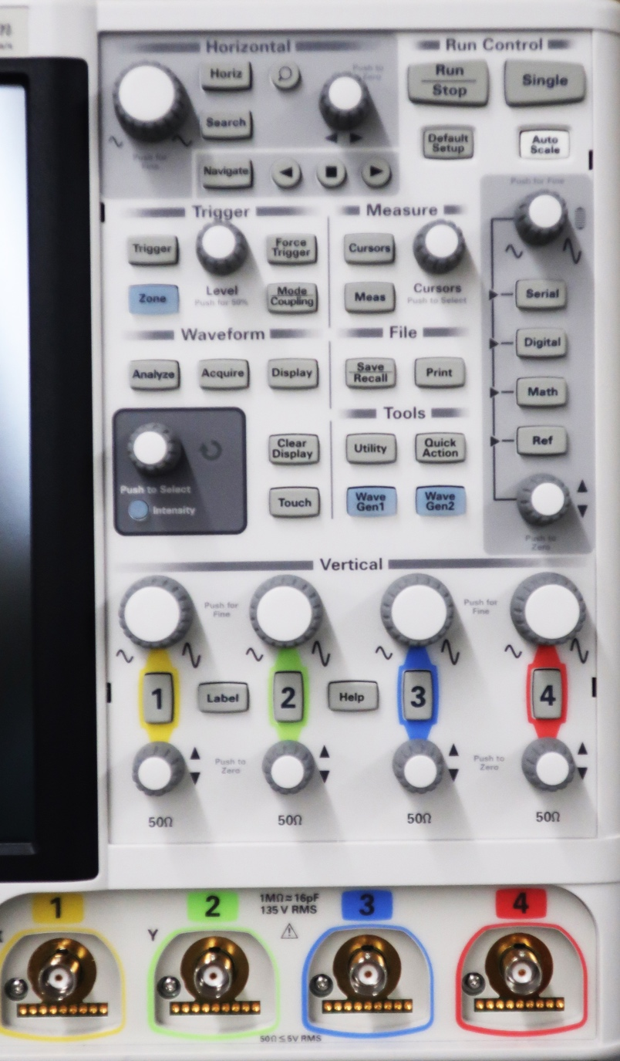

This puts the scope in a known state. If you ever get lost in the controls, pressing this button will reset the scope without turning it off.

4. This scope has a touchscreen that allows you to enter commands by touching softkeys and waveforms directly on the screen. The touchscreen functions operate only when the "Touch" button is lit. This button is near the right center of the front panel. Be sure this button is lit before using any commands on the touchscreen itself.

5. In what follows, you will measure the peak-to-peak amplitude and frequency of the internal test square wave generated by the scope for calibration purposes.

6. Connect a 1x/10x scope probe (Tektronix P2220 or equivalent) to the BNC jack (socket):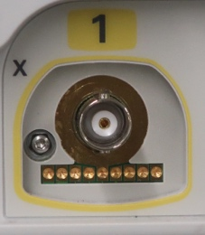

on the front panel labeled "1". BNC connectors are bayonet-type connectors. The shell on the plug:

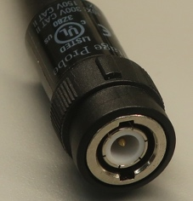

should be aligned with the side pins jutting out from the socket so as to allow insertion of the plug into the socket. Then, you should grasp the shell and twist it 1/4 turn clockwise until you feel it stop. This locks the connector in place.

7. Your scope probe:

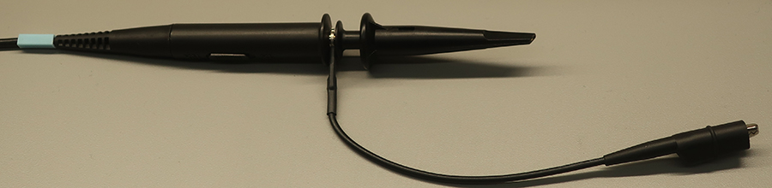

should have an alligator clip lead coming off to the side, and a hook tip that is exposed:

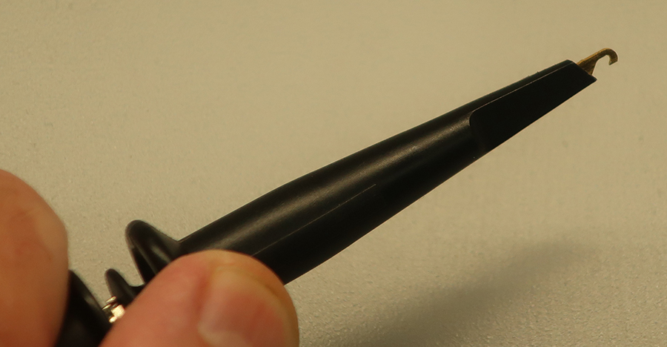

by pulling down on the rear of the tip cover. If your probe has just a bare sharp needle at the tip, exchange it for one that has a tip cover attached.

The alligator clip lead is the ground lead of the probe. It is good practice always to **connect the ground lead first** and **disconnect it last** to whatever system you are measuring. Find the horizontal metal bar with two holes in it that sticks out from the bottom center of the panel:

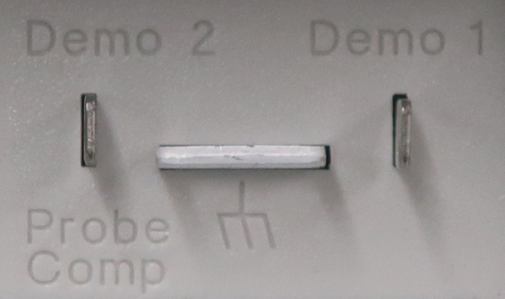

It is above a "chassis ground" symbol: 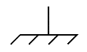. This is the scope's ground terminal. Connect the alligator clip to this ground terminal.

8. There is a vertical metal tab to the left of the ground terminal. The vertical tab is labeled "Demo 2 — Probe Comp". Clip the hook tip of the scope probe to the Probe Comp terminal.

9. On the screen, the Channel 1 (yellow) trace should now show some movement. The quickest way to obtain a stable trace is to press the "Auto Scale" button near the upper right center of the front panel. Press this button, and the scope should automatically select the horizontal (time/division) and vertical (voltage/division) settings that will give a readable trace.

10. After pressing "Auto Scale" you should see five or six cycles of a square wave. If you do not, ask the instructor for help.

11. Your scope probe has a 1x/10x slide switch on its side, on the probe body:

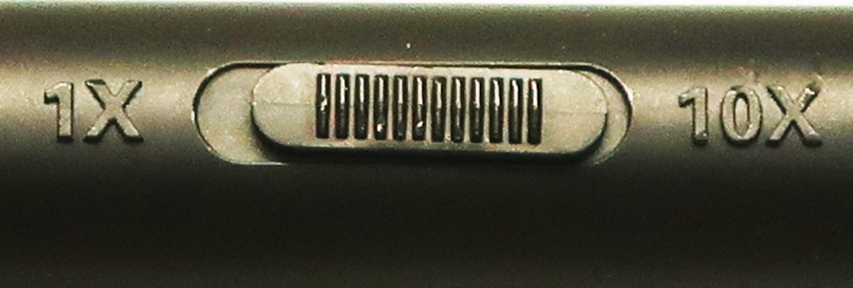

Make sure it is set to ***1x*** for this experiment.

12. Next, make sure the scope's Channel 1 probe ratio setting agrees with the actual probe setting of 1.00:1 (1x). Press the button labeled "1" above the Channel 1 BNC jack. You should then see a softkey labeled "Probes." With "Touch" on, touch the "Probes" softkey.

13. You should then see a softkey near the bottom left of the screen that says "Probe" followed by a ratio (e. g. 1.00:1 or 10.0:1). To make the scope's probe ratio match your probe setting, the ratio should be 1.00:1. If the scope's probe ratio setting does not match the actual probe setting, all your voltage data will be wrong.

If the ratio is not set to 1.00:1, touch the "Probe" ratio softkey **twice**. This should cause a panel to appear with a numeric keypad on it. You should enter "1" on the keypad and then touch "Enter". This will set the scope probe ratio to 1.00:1.

14. To measure the peak-to-peak amplitude of the square wave, press the "Meas" button in the "Measure" area of the front panel. This operation will show the measurements that are currently being made by the scope. If "pk-pk" is not displayed, touch the "+" softkey on the "Meas" panel on the right side of the screen. This should produce a long menu of possible measurements. Slide it until you can see "Peak-Peak" in the "Voltage" category. Select this choice from the menu by touching it. This should add it to the measurement list. If it is already there when you press the "Meas" button you need not add it again.

**Record the peak-to-peak voltage from the measurement here:**

**Calibration square wave V(p-p) = 2.61 V**

15. To measure the approximate frequency of the square wave, press the "Meas" button and select "Frequency" under the "Time" category. Read the frequency of the waveform.

**Record the frequency from the measurement here: *f* (Hz) = ___953.63 Hz__________**

16. Disconnect the scope probe (tip first, ground alligator clip last), turn off the scope, and this part of the lab is complete.

**Part 2: Power Supply and Digital Voltmeter (DVM)**

**Objective:** To familiarize the user with the operation of the Keysight E36311A power supply and Keysight 34460A digital multimeter (DVM).

**Procedure:**

1. This power supply has three outputs connected as follows:

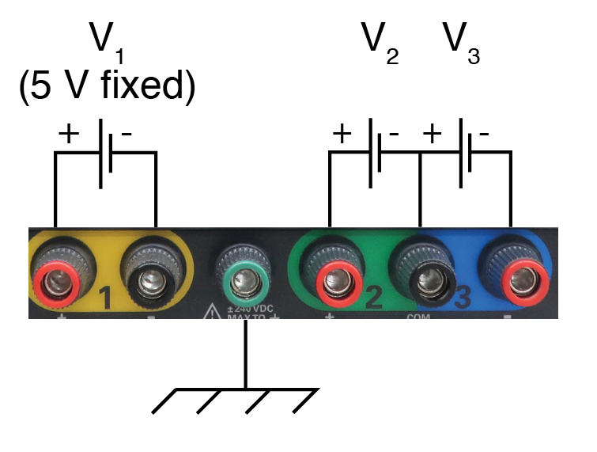

In this lab, you will use only the pair of terminals labeled "*V2*." The green terminal with the chassis-ground symbol is normally not used at all unless there are shielding problems.

2. Turn on the power supply using the ON/OFF button in the lower left corner of the front panel.

3. When the software loads, you should see a screen with three sections labeled 1, 2, and 3, corresponding to the three voltage sources:

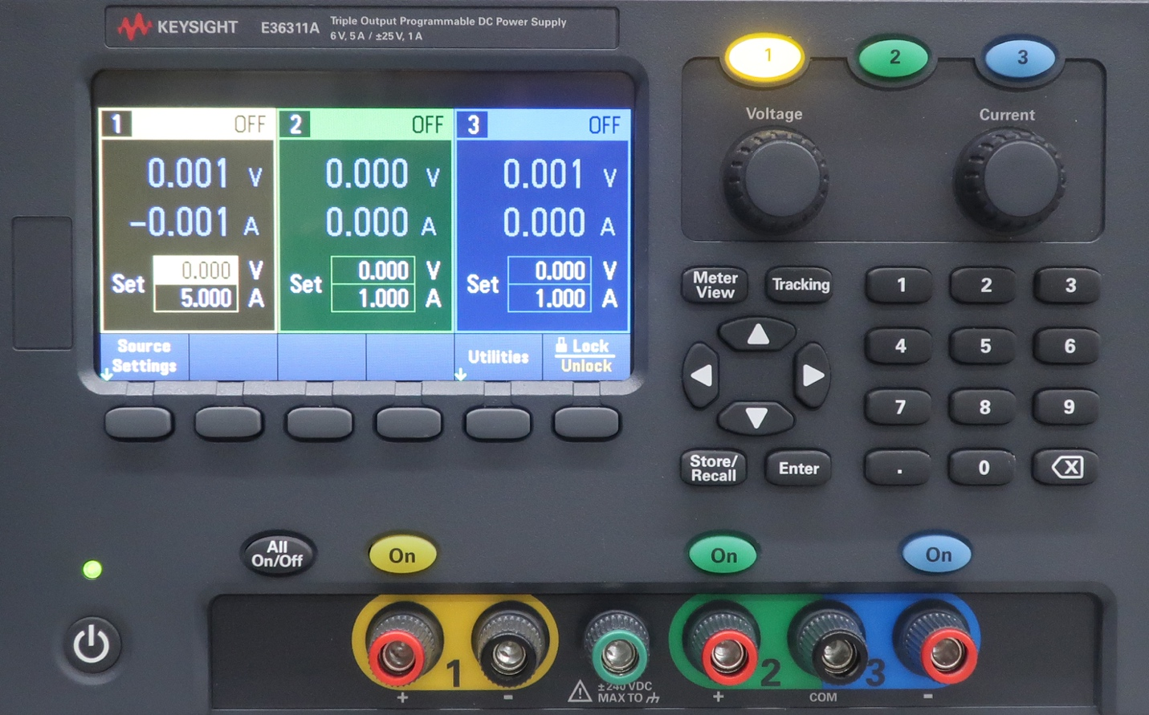

4. We wish to set voltage *V2* to 10.00 V. Press the green "2" button at the top of the panel. It should light up. The fastest way to set a voltage output is to use the keypad entry method, but you can make fine adjustments with the "Voltage" knob.

On the keypad, type "1" "0" and then press the "Enter" button. This should enter 10.000 V in the "Set" area of the *V2* screen panel.

5. Even if the power supply is on, no voltage appears at the output terminals until the button directly above the terminals is pressed so that it lights up. Press the green "On" button above the pair of terminals labeled "2." The main voltage reading on the *V2* screen should now read very close to 10.00 V.

**Record the power supply voltage reading here: __9.998 _____________V**.

6. Press the green "On" again to turn off the output. Then make the following connections between the power supply *V2* output terminals and the voltage input jacks of the DVM as shown:

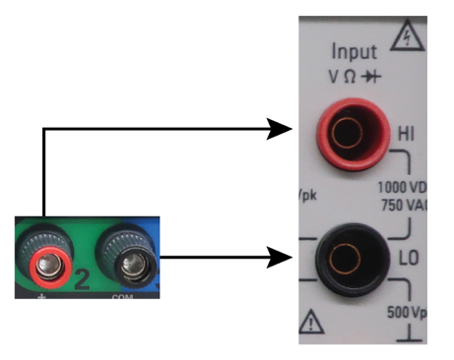

The DVM input jacks require **banana plugs**:

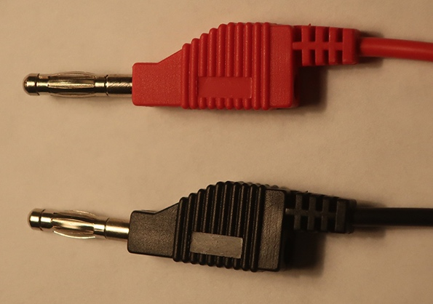

However, the power supply output terminals (called "**binding posts**") can accept banana plugs, **spade lugs** or even **alligator clips** in a pinch:

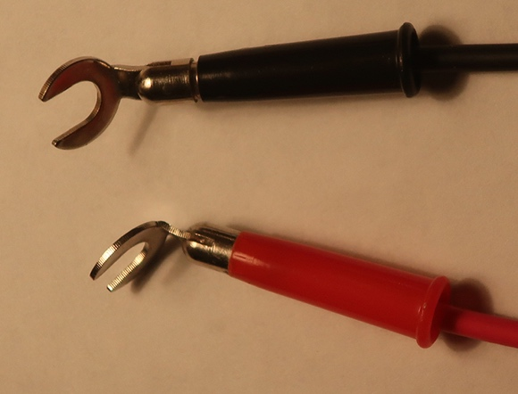 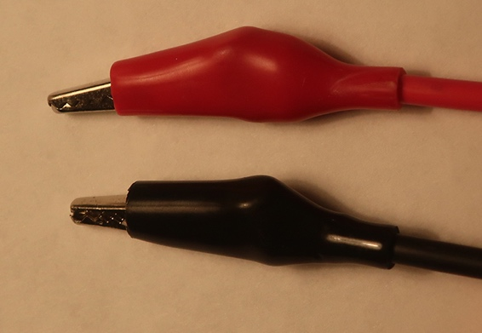

The binding posts will also accept **tip plugs** and **bare** (stripped) **wire**. Insert bare wires through the hole drilled in the binding-post shaft, which you can see if you unscrew the nut far enough. If you use bare wire with the power supply terminals, make sure the **bare wire touches the metal** of the binding post and no insulation interferes with the connection.

You may have to combine two different kinds of cables to get from the power supply to the DVM (for example, a cable that has spade lugs at one end and alligator clips at the other end, clipped to a cable with clip leads at one end:

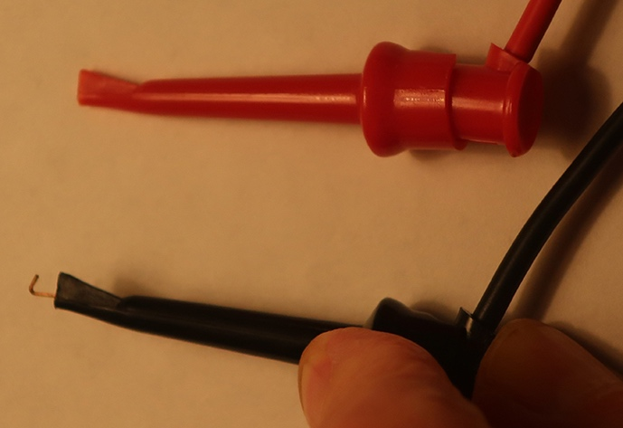 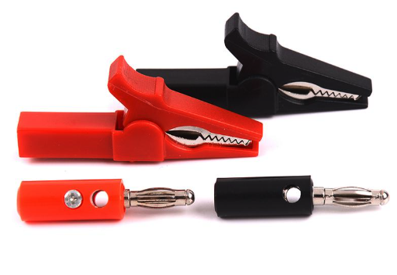

and banana plugs, or alligator clips at the other end).

Observe the polarity of the connections to the DVM (positive-red to positive-red). It is good practice to use red cables for positive and black cables for negative or ground. If you mix up the polarity, the DVM's polarity reading will be incorrect.

7. Turn on the DVM by pressing the ON/OFF button in the lower left corner of the front panel.

8. When the software starts up, press the button labeled "DCV" on the front panel. This sets the input circuitry of the DVM to measure voltage.

9. Turn on the power supply output by pressing the green "On" button above the *V2* output. The DVM should now read the output voltage of the power supply.

**Record the DVM voltage reading here: ____9.997k___________V**. It should be very close to the power supply's reading.

If you need to produce a very accurate voltage, you should rely on the DVM's measurement rather than the power supply's reading, although both are accurate enough for most purposes.

10. Turn off the power supply and DVM and return your wires and cables to their original locations.

Build the circuit with the three LEDs shown in the schematic. Experiment with different colors by using all 1 kilo-ohm and 10 kilo-ohm resistors and measure the voltage and current each LED receives.

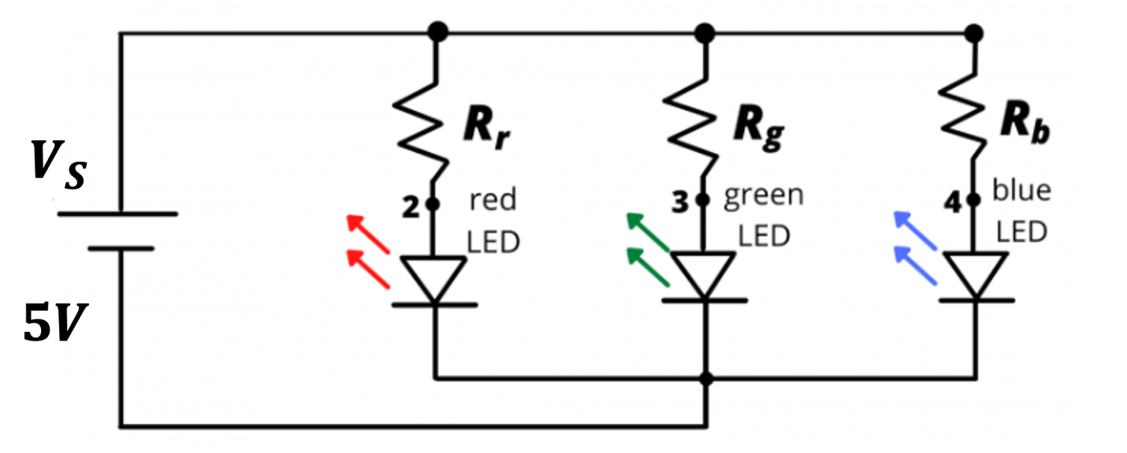

**11. Record the voltages and currents, and explain why they differ.**

Red = 1.88 V, 3.14 mA

Green = 2.449 V, 2.57 mA

Blue = 2.64 V, 2.36 mA

LED color comes from the semiconductor bandgap energy. Higher-energy photons (blue) require a larger forward voltage than red to start conducting and emitting.